(Approx. 628 words)

Making Your Tech “Fit”
Does Size Matter?
Author: Debra Carlson, Technical Advisor, CVC Computer Club, CO
Q2 2019 issue, Tech-Notes
cvc.computer.club (at) gmail.com

Last quarter we talked about tech and eyes. This quarter we will talk about something that can be related … Does size matter?

A few principles:

Keyboards -- “full size” addresses the width of keys but not the angle of the keyboard, height of the keys, pressure that is required to depress keys, or the optional keys and support for their programming.

“Ergometric keyboards” that force you to hold your elbows away from your body are “healthier”, in large part, because they force you to take breaks from typing. Keyboards with many curves do the same – and breaks are important.

Mouse -- If a mouse is too small it will stress your hand and wrist. It will also make it harder to relax while using the wheel for scrolling.

If you need to save money on one of these devices, save on the keyboard and spend on a mouse that fits.

Now for the more complicated size question – the monitor.
First, monitor size is both the physical size of the screen and the size of the items on the desktop (the screen with its icons, etc. is called the desktop).
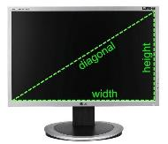
Many writers say, “get as big a monitor as you can afford.” While this may work for the newer high-end televisions, it is possible to overload the optical sensors at the distance we use for computer monitors.

Monitor size is measured diagonally.

Approximate sizes on your desk are shown below.
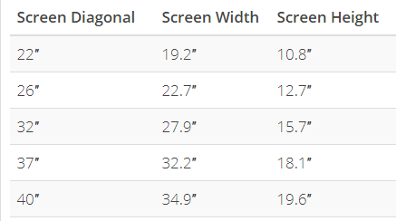
OSHA (US Occupational Safety and Health Administration) suggests the following setup.
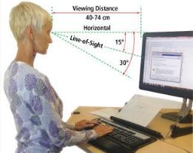
Optometrists suggest the monitor distance is 16 to 30 inches.

It is important to note that people who use bifocals / trifocals / progressive lenses will often need to look through the bottom of lenses if they do not use computer glasses so raising the monitor and setting it a bit farther back will help with neck strain.

It is important to place the monitor in a location that eliminates glare on the screen. This optimally means perpendicular to a window, but this may not always be possible.
Options include modifying the natural (shades / curtains), or artificial light (sometimes this means turning on a light) when using the computer.

Standard resolutions (icon and font sizes) for current monitors are (many more are possible):

1280x720
1366x768
1600x900
1920x1080

Generally, adjusting icon size more than 125% is not recommended unless you are using a discrete graphics card as it will cause slow response time and hanging / ghosting of images. Plan to mix changing resolution and setting icon size for best results.

It is usually possible to get a good 24” monitor for $150 and a good 27” for between $200 and $250. Be sure you have a desk with space that allows you to move a monitor away from the chair before investing in a 32” monitor because of optical overload potential … and invest in a 4K monitor if you are going that large to help avoid the pixilation that can happen on a large monitor.

If you are using a laptop, of course, sizes are different but resolution information is the same. Most laptops will allow attaching an external monitor for ease of use when sitting at a desk … check to see what kind of connection you can make. Most laptops will use VGA or HDMI.
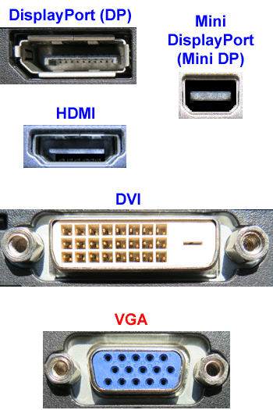
For all users – when replacing your monitor, futureproof your purchase by including DisplayPort or HDMI on the monitor or TV you purchase for your viewing pleasure.

Next month we will look at Things in your hands (mouse, stylus, pen mouse, finger, clicking, swiping, touching, and other stuff), followed by Cords, Voice, Sound, and other hazards.

